**CHAPTER 1**

**INTRODUCTION**

**I. HISTORICAL BACKGROUND**

***PAMANTASAN NG LUNGSOD NG MAYNILA***

*A Vision for Social Transformation*

Pamantasan ng Lungsod ng Maynila's conception started during the administration of Mayor Arsenio H. Lacson, the first elective mayor of the City of Manila in 1951, when he approved Ordinance No. 4202 on 13 January 1960. The Municipal Board has allocated P1-Million to establish the University. The Board's committee that spearheaded and allocated funds for the creation of the city university, in support of Mayor Lacson's educational program, was chaired by then-Councilor Ernesto M. Maceda. Mayor Lacson suddenly passed away while in office and before the fulfillment of his dream university. His then-Vice-Mayor, Antonio Villegas, succeeded him and worked for the realization of the dream university of his predecessor. On 13 February 1963, Mayor Villegas issued Executive Order No. 7, s-1963, creating a Planning and Working Committee to draw up a plan to establish the city university. The committee was chaired by Dr. Benito F. Reyes and the members were Gabriel Formoso, Leoncio Monzon, Alfredo Morales, Vicente Albano Pacis, Jose S. Roldan, and Carlos Moran Sison, with Atty. Primitivo de Leon as its secretary.

*Creation by National Legislation*

In 1964, Mayor Villegas co-opted the aid of then-Congressman Justo R. Albert of the 4th congressional district of the City of Manila to sponsor a bill in the House of Representatives of the Congress of the Philippines seeking to create the city university. Filed as House Bill No. 8349 in the Lower House, the Senate version was spearheaded by Senators Gil Puyat and Camilo Osias. In his explanatory note for H.B. 8349, Congressman Albert stressed that "the establishment of this university by the City of Manila will spur other cities in the country to exert similar efforts so that the responsibility of educating our people may be properly located." He articulated that according to a French philosopher, "next to food, education is the greatest need of the People." He likewise emphasized that "to permit the continuing control of education in the hands of big corporations is a tragic renunciation by the Government of a sacred obligation to our people. This bill envisions a partial relief of education from the grip of profit-motivated corporations and seeks a condition in which education is solely dedicated to the better instruction of our people."

The consolidation of the two bills was tackled during the Fourth Session of the Fifth Congress which began and was held in the City of Manila on 25 January 1965. The consolidated bill was thereafter passed by the joint Congress with the House of Representatives finally passing the same on 12 May 1965 while the Philippine Senate finally passed it on 07 June 1965. The final bill was signed by Senate President Ferdinand E. Marcos and House Speaker Cornelio T. Villareal with Mr. Regino S. Eustaquio, Secretary of the Senate, and Mr. Inocencio B. Pareja, Secretary of the House of Representatives.

*Presidential Approval of the Congressional Act*

On 19 June 1965, the final bill entitled "An Act Authorizing the City of Manila to Establish and Operate the University of the City of Manila and for Other Purposes" was signed into law by President Diosdado P. Macapacal in a signing ceremony in Malacañang Palace witnessed by Atty. Primitivo de Leon, Mayor Villegas, Congressman Ramon Mitra Jr., and its main sponsor in the House of Representatives, Congressman Albert. The law was captioned as Republic Act No. 4196 which now serves as the University Charter.

*A Day of Double Significance*

The birth of Pamantasan on a June 19 is made even more significant than ever by the fact that it was made to coincide with the birth of the Philippine national hero, Dr. Jose P. Rizal, who has a great aptitude for study, thereby earning several degrees and titles during his teen years with flying colors. Multi-talented as he was, Rizal's concept of the importance of education is clearly enunciated in his work entitled Instruction. For Rizal, the mission of education is to elevate the country to the highest seat of glory and to develop the people’s mentality. Since education is the foundation of society and a prerequisite for social progress, Rizal claimed that only through education could the country be saved from its sorry status. Rizal’s philosophy of education, therefore, centers on the provision of proper motivation in order to bolster the great social forces that make education a success, to create in the youth an innate desire to cultivate his intelligence and give him life eternal.

*The Seminal Direction*

The University was so named "Pamantasan ng Lungsod ng Maynila" from the official English name by Mayor Villegas in 1967. The Board of Regents, which is the governing body of the University, was formally formed in the same year as Mayor Villegas appointed its members. The university regents were sworn into office on 09 January 1967 which eventually conducted its first official board meeting and the election of its officers on 23 February 1967 at the Maharnilad. The composition of the first Board of Regents were: Atty. Carlos Moran Sison, chairman; Dr. Benito F. Reyes, vice-chairman; Emilio Abello, Roman F. Lorenzo, Jose S. Roldan and Primo L. Tongko, members; while Fructuoso R. Yanson served as an ex-officio member and Jose F. Sugay as its secretary. Dr. Reyes was elected as PLM's pioneer president, endowed with a herculean task of charting the roots of excellence that was to be the Pamantasan that is known today.

On February 5, 1970, then Executive Secretary Ernesto M. Maceda, by authority of then President Ferdinand Marcos, conveyed unto the City of Manila two (2) parcels of land owned by the Republic of the Philippines. Said real properties consist the area where PLM stands today. And as solemnly endeared and inscribed by every PLM member to his heart, the University formally opened the University College on Monday, 17 July 1967 with an initial enrollment of 556 outstanding and bright scholars carefully selected from the upper 10% of the various public high schools in Manila. Indeed, excellence has been a "birthright" of PLM. The PLM also established the Graduate College a year later, followed by the Institute for Extra-Mural Studies. And the rest was history in the making.

**VISION** (What we are)

The Pamantasan ng Lungsod ng Maynila (PLM), created by a National Charter (RA 4196, 1965), was envisioned to be Manila's premiere institution for higher learning. It provides superior standards of instructions, as well as opportunities for outstanding research in technology and other areas for the development of the intellect and to advance human knowledge.

The Pamantasan ng Lungsod ng Maynila has adopted the policy of preferential option for the poor and therefore has prioritized education for the underprivileged but talented students of Manila. Committed to the highest intellectual and ethical standards, PLM strives to produce competent graduates with integrity who will be responsible citizens who can contribute effectively to local, national and global initiatives for the progressive and sustainable development of humanity.

Guided by the values of academic excellence, integrity and social responsibility PLM endeavors to be one of the leading universities in the ASEAN.

***COLLEGE OF MEDICINE***

The Pamantasan ng Lungsod ng Maynila College of Medicine was established in June, 1983 with 48 medical scholars by virtue of Resolution No. 806, series 1980, passed on December 15, 1980 by the Board of Regents. It was envisioned from its conception that the College of Medicine will offer a unique, community-based medical education that will serve the health needs of the people of the city of Manila particularly those residing in depressed barangays as primary care physicians.

At the start, the program was on a full scholarship basis for poor but deserving Manila residents who have finished a pre-medicine course and have met the necessary requirements.  
  
Three years after its beginning, the College of Medicine opened its doors to qualified non-Manila residents under the socialized curriculum where their tuition fees were based on their parents' income. This marked the beginning of the classification of freshmen students having scholarships where the tuition and miscellaneous fees were either minimal or free.

Eventually another category was included for those students paying the full amount.  
  
On the fourth year of its operation, the College of Medicine opened the Community Medicine Residency Training program in line with its objective to provide medical care to the underserved of Manila. This enabled its students under the scholarship programs to render service.

After graduation, the medical graduates were assigned to Ospital ng Maynila Medical Center or other hospitals as intern (PGI). After they have passed the Medical Board Examinations and have obtained their license to practice, they were to serve the city for four years either as resident physicians at any other hospital owned and operated by the City of Manila, as faculty members at the College of Medicine or as a regular employee at the Manila Health Department (MHD).

In the following years, the community service program as a manner of giving back to the city of Manila underwent modification to suit the needs of the university and the other communities within the city of Manila including our very own university.  
  
To further enhance the development of the students and faculty of the college with regards to training and research particularly in the field of Community Medicine, the College of Medicine became a member of the Association of Philippine Medical Colleges Foundation (APMC), International Network Community-Oriented Educational Institutions for Health Services (based in Holland), Metro Manila Health Science Community and Philippine Council for Health Research Development. It was also affiliated with the following institutions: the University of Indonesia, the Gadjah Mada University in Yogyakarta, Indonesia, the University of Nebraska at Omaha Medical Center in the USA, and the San Lazaro Hospital.

Through the years the Pamantasan ng Lungsod ng Maynila College of Medicine has gained recognition and respect as one of the premiere medical schools in the Philippines being consistently in the Professional Regulations Commission's (PRC) list of top 5 colleges in the Physician Licensure Examinations.

Because of the exemplary performance of its graduates, three years after it has produced its first batch it was given full accreditation as a medical school.  
The college has produced several board placers and physicians who have become noted in their respective medical specializations and service to the community. The graduates were given opportunities to give back to the College of Medicine and the city of Manila and the nation as faculty members, health service providers in the university, Manila health centers, government hospitals under the city of Manila, and the Manila Health Department and community health organizers and providers in the Count-Me-In Program.  
  
Because of the College of Medicine's noble vision and because of the impressive performance of its graduates, it has been included in the list of schools granted scholarships for medical students namely the PCSO-DOH Pinoy MD Medical Scholarship Program and the "Bagong Doktor Para sa Bayan" from 2000-2010.

The aim of the College of Medicine has always been to produce medical graduates who strive for academic excellence and develop the passion for further training, research and community-service. With the efforts of its administration and faculty and the contributions of its graduates, the institution will continue its pursuit of being a center committed to excellence in providing quality medical education, training, research and service that is community-oriented.

**The Vision & Mission of the College of Medicine**

In line with the university's mission and vision, the PLM College of Medicine aims to be a professional school committed to excellence in community-oriented medical education, training, research and service; an excellent center for the education and training of medical professionals who are highly competent, globally competitive, ethical, caring and dedicated to serve the health needs of the city of Manila, the nation and the world.  
Guided by this mission, the PLM College of Medicine seeks:

• To produce excellent community-oriented medical practitioners who value human life and promote health and wellness.

• To nurture the ideals of nationalism and the values of social sensitivity and responsibility, holistic care with compassion and dedication to the medical profession.  
• To create a culture of academic excellence and social responsibility among the administrators, faculty and staff.

• To provide quality and relevant researches.

• To strengthen local, national and international linkages that will contribute to quality medical education.

**II. ORGANIZATIONAL CHART**

**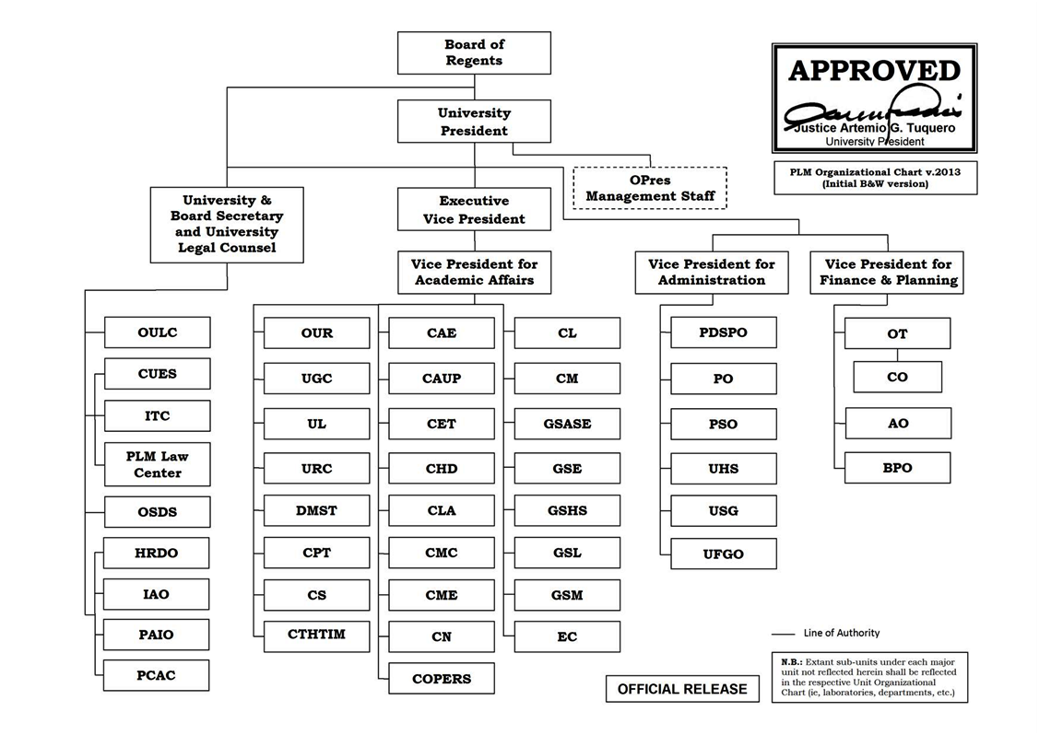 *COMPANY AS A WHOLE***

: Division under study

***DIVISION UNDER STUDY***

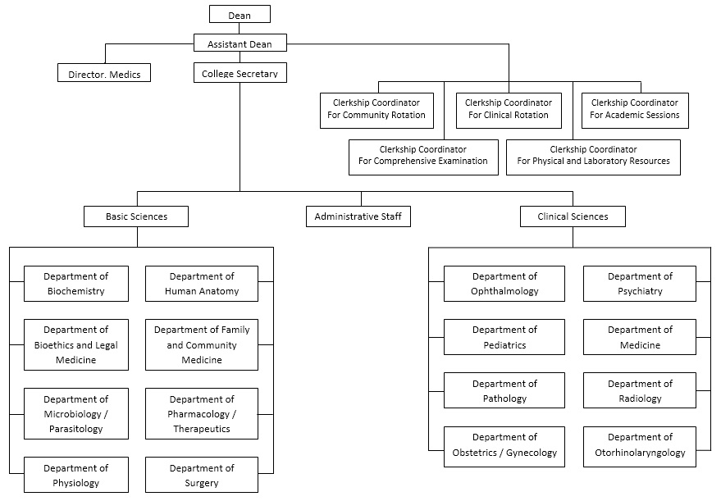

**III. STATEMENT OF THE PROBLEMS**

**1. Time Consuming in Generating Official Questionnaire**

**Document(s) involved**

* Blueprint Outline – guidelines in determining the type of questions whether they fall under remembering, understanding, application, analysis, evaluation or creation.
* Textbooks – official reference used on creating questions.
* Questionnaire draft - list of questions created by the faculty.
* Blueprint – constructed structure of the questionnaire draft.
* Official Questionnaire – questionnaire used for the examination.
* Item Analysis Report – result of the examination including the difficulty and discrimination of each questions.

**Scenario**

Every year the College of Medicine conducts four shifting exams in each department. Each department delegates three to five faculties to create a questionnaire draft. Usually the draft consists up to 100 to 200 questions. Each and every shifting exams the faculty will likely start from scratch. Each faculty has to base his or her questions on the blueprint outline given to him or her by the chairman then compare each question to the previous shifting exam if it existed. If the question existed on the previous shifting exam, the faculty needs to determine its validity. If the question is valid, the question will remain but when it is invalid, the question will be either rephrased or removed. After gathering the questions the faculty will determine which type the question falls into and he or she has to do this to all the questions. When they finished creating the questionnaire draft they will submit it to the chairman of their department. The chairman cannot start evaluating the questions until all faculties submitted their drafts. After consolidating all questionnaire drafts from the faculty, the chairman will evaluate and review all the questions submitted and further check their validity to ensure the reliability of the question. After evaluating and reviewing all the question, the chairman will gather questions for generating the official questionnaire. Lastly, if the official questionnaire was created it will be printed and distributed to the faculty for examination proper.

**Cause**

* Each faculty starts from scratch every time they create a questionnaire draft.
* Each question needs to be checked if it existed on the previous exam.
* Same process is done between faculty and chairman.

**Impact**

* Time for other work was spent on generating the exams.

**Quantification**

|  |  |
| --- | --- |
| Hours allotted for working | 4 hours |

**GENERATING QUESTIONNAIRE DRAFT**

|  |  |
| --- | --- |
| Gather possible questions and determining its type | 1 min x 100 = 100 minutes or 1 hour and 40 minutes |
| Typing the gathered questions | **2 min x 100 = 200 minutes or 3 hours and 20 minutes** |

**Time spent on validating each questions = 254 minutes or 4 hours & 14 minutes**

|  |  |
| --- | --- |
| Time it takes to retrieve previous shifting exam | 2 minutes |
| Time it takes to retrieve previous item analysis | 2 minutes |
| Time it takes to search the preferred question | 2 minutes |
| Time it takes to determine the validity of the preferred question | 1 minute |
| Total time to retrieve the validity of the first question | 2+2+2+1 = 7 minutes |
| Total time it takes to check the validity of 100 questions | 7+((2+1)*99) = 304 minutes or 5 hours and 4 minutes |
| Total time it takes to check the validity of 100 questions but doesn’t exist on the previous shifting exam | (2+2+2)+(2*99) = 204 minutes or 3 hours and 24 minutes |
| Average time of checking the validity of the existing and non-existing questions | **(304+204)/2 = 254 minutes or 4 hours and 14 minutes** |

**Finalizing the Questionnaire Draft = 50 minutes**

|  |  |
| --- | --- |
| Finalizing the questions and revisions | 30 minutes |
| Satisfying the Objective of the Blueprint and revision of questions | **20 minutes** |

|  |  |
| --- | --- |
| Total time on Generating the Questionnaire Draft | 100 + 200 + 254 + 30 + 20 = 604 minutes or 10 hours and 4 minutes |
| Days Spent on Generating the Questionnaire Draft | **10 hours and 4 minutes/ 4 hours = 2.52 days (AVERAGE) 3 days** |
| Days it take to generate official questionnaire | **604+(3*254)+30+20 = 1416 minutes or 5.9 days (AVERAGE) 6 days** |

**2. Inaccurate Report on the Item Analysis**

**Document(s) Involved**

* Item analysis - result of the examination including the difficulty index, discrimination index, mean, standard deviation, reliability index and standard error.

**Scenario**

After the examination proper, the chairman, dean and MEDICS director evaluates the examination using the item analysis generated by the scantron machine. They review the results of the examination like the; scores, mean, standard deviation, reliability index and standard error for analyzing its efficiency and determine whether the examination satisfies the blueprint’s objective or not. The higher officials (chairman, dean and MEDICS director) usually don’t rely on the results of the reliability index because they prefer the results of the standard method in which they do it manually but they don’t want to manually compute the analysis because the process is time consuming. The acceptable index of the standard method for reliability index is from .70 and above. Meanwhile, the acceptable index for the existing system’s reliability index range down from .60 and above.

**Cause**

* Existing item analysis doesn’t use the standard computations

**Impact**

* Poor evaluation of the examination

**Quantification**

|  |  |
| --- | --- |
| Standard Result of the Acceptable Reliability Index | .7000 or above |
| Reliability Index of PHARMA 1ST COMPRE SY 14-15 | **0.6025** |
| Percentage Error of the Standard Method and the Existing System’s Reliability Index | $$\frac{(.7000-0.6025)}{0.7000}×100\%=13.93\%$$ |

**3. Incomplete Statistical Report**

**Document(s) Involved**

* Item analysis - result of the examination including the difficulty index, discrimination index, mean, standard deviation, reliability index and standard error.

**Scenario**

After the examination, the scantron will generate the statistical analysis which includes the Discrimination index, Difficulty index and Examinee Ranking. The faculty will distribute the reports for documentation to the Dean, MEDICS director and chairman. The students will also receive their scores for them to determine whether they passed or failed. The statistical analysis is only for the benefit of the quality of the next examination. The system lacks the information necessary for assessing the further outcome of the future examinations and also for predicting the result of major examinations such as the passing rate of the students for board examinations.

**Cause**

* The system generates result that lacks information to be considered a statistical report.

**Impact**

* Unable to track/monitor the progress of the students.
* Difficulty to assess the result of the future examinations.

**4. The paper-based examination is fully exposed to the dangers of cheating**

**Document(s) Involved**

* Official Questionnaire – questionnaire used for the examination.
* Scantron Sheet – specific paper used by the scantron machine

**Scenario**

Administering a paper-based examination is prone to various forms of cheating at various stages due to total lack of controls attending the examination proper. Considering that the questionnaires are identical, examinees tend to fall towards basic forms of cheating like peeking on someone else’s answer sheet, especially when the faculty suddenly attends to something else, at worst leaving the room for some extended errands.

**Cause**

* Using identical exam questionnaires increases the chances of cheating of examinees.

**Impact**

* Faculty experiences difficulty in handling examination proper.
* The progress of the student’s proficiency tends to get stagnant.

**5. Misprints or smudged words on the questionnaire leads to errors and disturbance on the examination proper**

**Document(s) Involved**

* Official Questionnaire – questionnaire used for the examination.

**Scenario**

The examination proper includes the generation and distribution of official questionnaires and scantron sheets to the students. Each student must have a copy of the questionnaire. Due to expensive printing services the college is dependent usually on photocopying services, the reproduction stage naturally produces misprints or smudged copies. This smudged words or misprints are not likely seen nor checked by the faculty for necessary corrections. The distortions and misprints may lead to misinterpretation of the question or difficulty in understanding the question that further leads to mistakes. Sometimes the students ask the faculty about the misprints and smudges for correction and verification to prevent mistakes.

**Cause**

* The production of questionnaires is dependent on photocopying services.
* The smudges and misprints on the copies are not checked by the faculty.
* Inquiring of students during examination

**Impact**

* Difficult to understand the smudged or misprinted questionnaires.
* Smudged words tend to lead to mistaken answers.
* Smudged words affect the student’s score.
* Verification of a student related on the question adds more time

**6. Wastage of paper after the examination**

**Document(s) Involved**

* Official Questionnaire – questionnaire used for the examination.

**Scenario**

Every year the College of Medicine conducts four shifting exams in each department. There is an average of 500 students enrolled in the college that takes the shifting exams. A questionnaire is generated to accommodate each students on the examination proper and each faculty, the chairman and the MEDICS director has the copy of the official questionnaire for further analysis and documentation. After every shifting exams, the questionnaires used by the students will be returned to the faculty. The questionnaires given to the faculty will be stored to the filing cabinet and will not be used again. The questionnaires given to the faculty, chairman and MEDICS director before the examination are the only copies needed for further evaluation and documentations.

**Cause**

* Copies of questionnaires from the faculty, chairman and MEDICS director are the only copies needed

**Impact**

* Papers that might be used for other important purposes are used.

**Quantification**

|  |  |
| --- | --- |
| Average number of students | 500 students |
| Average pages of questionnaires | 3 pages |
| Average number of wasted papers | 500 x 3 = 1500 papers |
| Average number of wasted papers per year | **1500 x 4 = 6000** |

**IV. SCOPE AND LIMITATIONS**

This study will be focusing on the Examination Generating and Automated Examination System of the Pamantasan ng Lungsod ng Maynila's College of Medicine. It includes the generation of questions for an exam, recording of the scores of each student, as well as the retrieval of records of a student's history of examination. It also includes the generation of Statistical Analysis, where we can see the Difficulty Index and Validity of each questions, and the Discrimination Index, where we can see how many students were able to answer a certain question. The study aims to improve the quality of examination in order to maintain academic excellence of the college. This study will not include the creating of questions for the exam.